Final Project Report

Online Job Portal for Alumni Network



Project Supervisor
Muhammad Tahir Jan

Submitted By

Shahroz Pervez (BC210426295)

Software Projects & Research Section,
Department of Computer Sciences,
Virtual University of Pakistan


CERTIFICATE

This is to certify that Shahroz Pervez (BC210426295) have worked on and completed their Software Project at Software & Research Projects Section, Department of Computer Sciences, Virtual University of Pakistan in partial fulfillment of the requirement for the degree of BSIT under my guidance and supervision.

In our opinion, it is satisfactory and up to the mark and therefore fulfills the requirements of Bachelor in Information Technology.

Supervisor / Internal Examiner

Supervisor,
Software Projects & Research Section,
Department of Computer Sciences
Virtual University of Pakistan

___________________
(Signature)

External Examiner/Subject Specialist
<<External Supervisor Name>>

___________________
(Signature)

Accepted By:

_____________
(For office use)

EXORDIUM

In the name of Allah, the Compassionate, the Merciful.

Praise be to Allah, Lord of Creation,
The Compassionate, the Merciful,
King of Judgment-day!

You alone we worship, and to You alone we pray for help,
Guide us to the straight path

The path of those who You have favored,

Not of those who have incurred Your wrath,
Nor of those who have gone astray.

DEDICATION


IN THE NAME OF ALLAH THE MOST BENIFICIENT THE MERCIFUL

I dedicate this Project to my beloved
Father & Teachers
And
To the Loving memory of my mother
And also
To my brothers & sisters.
You have successfully made me the person I am becoming
You will always be remembered.
ACKNOWLEDGEMENT
Foremost, I am highly grateful to Allah for His blessing that continue to flow into my life, and because of You, I made this through against all odds.

With a great pleasure I would like to acknowledge the support, assistances and contribution made by individuals from the beginning of the Project, providing me access, data and information, to the writing process until the completion of this project.
First of all, I want to give thanks to our project supervisors Asma Batool for the access and assistance in order to make my project possible.
Second, I would like to thank all the Mater program staff, thank you all for the assistance and constructive discussions we had during the entire courses

PREFACE

This project report has been prepared in fulfillment of the requirements for the Bachelor of Information technology in the academic year 2019-2026.

For preparing of the project report, I have closely studied the Personalized Daily planner of certain compounds to get the knowledge of the data requirements that will be used successfully to protect any entrance breaches.

I have also studied the software that was required for this project coding like, Python.

This project started with to test phases I which have given me the ability to understand the concept of programming and move me forward smoothly.

I am very thankful to my supervisors who have helped me to complete this project and I really appreciate all his efforts and support.

I am also very thankful to Virtual University, Pakistan and all the staff.
TABLE OF CONTENTS

CHAPTER NO. 1
gathering & Analyzing info 9

1.1 Introduction………………………………………………………10

1.2 purpose……………………………………………………………..10

1.3 scope ………………………………………………………………..10

1.4 definitions, acronyms and abbreviations……………….…..11

1.5 Project requirements…………………………………………..11

1.5.1 Functional Requirements…………………………………..…..11

1.5.2 Non-Functional Requirements……………………………..…..12

1.6 use cases and usage scenarios …………………………….…..13

1.6.1 Use Case Diagrams……………………………………………..13

1.6.2 Usage Scenarios…………………………………………….…..14

1.7 Development Methodology……………………………..……..21

1.7.1 Chosen Methodology…………………………………………...21

1.7.2 Reasons for Chosen Methodology……………………….……..21
1.7.2 Work Plan (Gantt Chart) …………………………………..…..25
1.7.2 Project Schedule (Submission Calendar) ……………….……..25

CHAPTER NO. 2
designing the project 26

2.1 Introduction……………………………………………..………..27

2.2 purpose……………………………………………….…………....27
2.3 scope ………………………………………………………………..27
2.4 definitions, acronyms and abbreviations…………………....27

2.5 Architectural Representation (Architecture Diagram) ...28

2.6 Dynamic Model: Sequence Diagrams……………………..…..29

2.7 Object Model/Logical Model: Class Diagram……………..38

2.8 Database Model (Database Diagram) …………………….…..39

2.9 Graphical User Interfaces……………………………….……..39

Chapter no.3
DEvelopment 41
3.1 Development plan (Architecture Diagram) ………………....42

CHAPTER 1
Gathering & Analyzing Info

Introduction
In the evolving landscape of educational institutions, maintaining a strong connection with alumni is vital for career development and networking opportunities. This web-based platform will serve as a bridge between alumni, current students, and employers, facilitating job postings, applications, and professional networking. The portal will allow alumni to share career opportunities, students to seek internships or jobs, and employers to post vacancies, fostering a mutually beneficial ecosystem.
The system will feature a secure login for different user types (alumni, students, employers), profile management with resume uploads, and a job matching mechanism based on skills and experience. It will include an admin dashboard for oversight, ensuring data integrity and generating reports on job trends or user activity.

Purpose
In the evolving landscape of educational institutions, maintaining a strong connection with alumni is vital for career development and networking opportunities. This web-based platform will serve as a bridge between alumni, current students, and employers, facilitating job postings, applications, and professional networking. The portal will allow alumni to share career opportunities, students to seek internships or jobs, and employers to post vacancies, fostering a mutually beneficial ecosystem.
The system will feature a secure login for different user types (alumni, students, employers), profile management with resume uploads, and a job matching mechanism based on skills and experience. It will include an admin dashboard for oversight, ensuring data integrity and generating reports on job trends or user activity.
Scope
In the evolving landscape of educational institutions, maintaining a strong connection with alumni is vital for career development and networking opportunities. This web-based platform will serve as a bridge between alumni, current students, and employers, facilitating job postings, applications, and professional networking. The portal will allow alumni to share career opportunities, students to seek internships or jobs, and employers to post vacancies, fostering a mutually beneficial ecosystem.
The system will feature a secure login for different user types (alumni, students, employers), profile management with resume uploads, and a job matching mechanism based on skills and experience. It will include an admin dashboard for oversight, ensuring data integrity and generating reports on job trends or user activity.

Definitions, Acronyms and Abbreviations

Terms | Definition
Web Programming/System | Book Recommender System
SRS | Software Requirement Specifications
VU | Virtual University of Pakistan
Deliverables | These are the documents prepared during development life cycle of the SW project
GUI | Graphical User Interface
MySQL | A type of database management system
PW | Password
SW | Software
Project requirements
  - Functional Requirements
- User Authentication and Role Management
  - Secure login and registration for three user types: alumni, students, and employers, with role-based access control.
  - Password reset and account verification via email.
  - Admin access to manage all user accounts and resolve disputes.
- Profile Creation and Management
  - Users can create detailed profiles including education, skills, experience, and contact information.
  - Upload and update resumes or portfolios as PDF files.
  - Option to mark profiles as public or private for visibility control.
- Job Posting and Application System
  - Employers and alumni can post job listings with details (title, description, location, salary range, skills required).
  - Students and alumni can apply to jobs with a click, attaching their resume.
  - Application status tracking (e.g., applied, shortlisted, rejected) visible to applicants and employers.

- Job Search and Matching Algorithm
  - Search functionality with filters (e.g., job type, location, skills) to find relevant opportunities.
  - Basic matching algorithm to suggest jobs based on user profile data (e.g., matching skills or experience).
  - Bookmarking feature for users to save preferred job listings.
- Notification System
  - Email notifications for new job postings, application updates, or system alerts (e.g., using Django’s email backend).
  - In-app notifications for real-time updates on application status or new matches.
- Admin Dashboard and Reporting
  - Admin interface to approve or reject job postings and user registrations.
  - Generate reports on job statistics (e.g., number of postings, applications per month) and user activity.
  - Export reports as CSV or PDF files for archival purposes.
- User Interaction and Feedback (Optional)
  - Message system for users to communicate directly (e.g., employer to applicant inquiries).
  - Feedback form for users to report issues or suggest improvements, logged for admin review.
- Data Security and Backup (Optional)
  - Implement basic security measures (e.g., input validation, CSRF protection) to safeguard user data.
  - Periodic database backup feature for data integrity, accessible to admins.

  - Non-Functional requirements:
- Security:
This application will be secure. This site provides an easy way for you to find diagnostic center that meet your needs. Security has been built into the project and we guarantee it.

- Usability:
User friendly interface will be provided so that user can interact easily. The Diagnostic Center Finder helps you find the right lab to suit your needs by walking you through a few easy steps.
- Responsive:
This application will be responsive. It will look good on all devices like PC, Tablets and Mobile Phones.

- Reliability:
This application will consistently perform the specified functions without failure. If failure occurs, the application will display an error message showing the root cause of the failure.

- Availability:
This application will be able to function during normal operating times.

- Efficiency:
Response time will be quick. It will use very less storage and computational resources.

- Maintainability:
This application will be easy to maintain because it will be built in good architecture and using well coding techniques.

- Portability:
This application will be portable on any platform due to the nature of the web.

- Confidentiality:
This application will protect sensitive data and allows only authorized access to data. General Information just only for unregistered users.
Use cases and usage scenarios
Use Case Diagrams

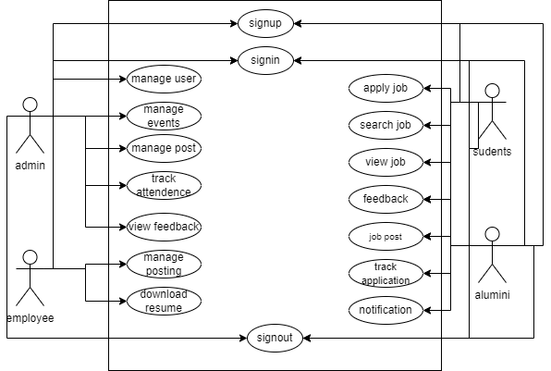

- Usage Scenarios:

Use Case Title | Register
Actor | Students, Alumni
Use Case ID | UCI_1
Actions | This app representative clicks the Signup button on the Event Management Panel and completes the signup form.  Students, Alumni view the signup button. Click it and fill the registration form and submit it
Description | The Panel allows a representative to register by completing an online form that includes mandatory fields such as company name, email, password, and contact details.
Alternative Path | If the signup process fails due to validation errors (e.g., missing fields, invalid email format) or technical issues, an error message is displayed prompting the user to correct or retry.
Pre-Condition | The application is running, and the user accesses the Signup option from the main menu
Post Condition | Upon successful submission, the new account is added to the database, and the representative is notified of successful registration.
Author
Exceptions | - Server errors preventing the registration.  - Validation errors due to incorrect or incomplete form inputs.  - Network issues interrupting the submission process.

Use Case Title | Login
Actor | Admin, Students, Alumni
Use Case ID | UCI_2
Actions | Admin, Students, Alumni will click on login link.  Admin, Students, Alumni will provide his unique Id and password to login on application.  System will check the password and ID if it exists than user will be granted access
Description | Login option will give permission to user to enter his account
Alternative Path | If the login process fails due to invalid Email or password or technical issues, an error message is displayed prompting the user to correct or retry.
Pre-Condition | Event Organizer, Attendee must have account ID and Password
Post Condition | Successful login to the system
Author
Exception | - Server errors preventing the registration.  - Validation errors due to incorrect or incomplete form inputs.  - Network issues interrupting the submission process.

Use Case Title | Create Event
Actor | Admin
Use Case ID | UCI_3
Actions | Admin can login
Description | The admin can create a new event by providing event details such as name, date, location, and description. The system saves the event in the database and makes it accessible to attendees.
Alternative Path | Form Validation Error Display
Pre-Condition | The Event Organizer must be logged into the system.  The database connection is active.
Post Condition | A new event record is saved in the database.  The created event appears in the organizer's list of events.
Author
Exceptions | - Server errors preventing the registration.  - Validation errors due to incorrect or incomplete form inputs.  - Network issues interrupting the submission process.

Use Case Title | Manage Post
Actor | Admin
Use Case ID | UCI_4
Actions | Admin can login
Description | The admin can create a new post by providing post details such as name, date, and description. The system saves the post in the database and makes it accessible to attendees.
Alternative Path | Form Validation Error Display
Pre-Condition | The Event Organizer must be logged into the system.  The database connection is active.
Post Condition | A new post record is saved in the database.  The created post appears.
Author
Exceptions | - Server errors preventing the registration.  - Validation errors due to incorrect or incomplete form inputs.  - Network issues interrupting the submission process.

Use Case Title | Track Attendance
Actor | Admin
Use Case ID | UCI_5
Actions | Admin can login
Description | The admin tracks attendance for events by marking attendees. Attendance data is saved in the system and can be accessed for reporting and analytics purposes.
Alternative Path | If an invalid event or attendee is selected, the system displays an error message and requests valid input.
Pre-Condition | The admin must be logged into the system.  The event must exist in the database.  The attendee list for the event must be available.  The database connection is active.
Post Condition | Attendance records are saved in the database.  Attendance reports are accessible to the Admin.
Author
Exceptions | - Server errors preventing the registration.  - Validation errors due to incorrect or incomplete form inputs.  - Network issues interrupting the submission process.

Use Case Title | View Event
Actor | Students, Alumni
Use Case ID | UCI_6
Actions | Students, Alumni can login
Description | The Students, Alumni Can Delete a event by providing
Alternative Path | Form Validation Error Display
Pre-Condition | The Students, Alumni must be logged into the system.  The database connection is active.
Post Condition | A Modified event record is saved in the database.  The View event appears in the organizer's list of events.
Author
Exceptions | - Server errors preventing the registration.  - Validation errors due to incorrect or incomplete form inputs.  - Network issues interrupting the submission process.

Use Case Title | Apply Internship
Actor | Students
Use Case ID | UCI_7
Actions | login into the application
Description | The student logs into the application to browse available internship opportunities. The system displays a list of internships. The student can view internship details, apply for specific opportunities, and submit their profile data directly to the employer.
Alternative Path | If no internship opportunities are available, the system displays the message: "No internship opportunities available at this time."
Pre-Condition | - The student must have a valid account and be logged into the system.  - The system must have access to the database containing internship information.  - The student’s profile must be complete with all required details.
Post Condition | The student’s application is saved in the database.  The employer receives the application details.  The student can track their application status through the system.
Author
Exceptions | Server Errors:  If the system encounters server issues, the Event Organizer will be notified with an error message and options to retry later.  Validation Errors:  If the input data is incomplete or invalid (e.g., missing attendee names or contact details), the system will prompt the Event Organizer to correct the entries.  Network Issues:  If the connection is lost during the process, the system will display an error message and allow the Event Organizer to retry once the connection is restored.  - Network issues interrupting the submission process.

Use Case Title | Participate Event
Actor | Students
Use Case ID | UCI_6
Actions | Students will login on the system
Description | The student logs into the system, navigates to the "View Events" section, and browses all available events. Students can choose to participate by registering for a specific event.
Alternative Path | N/A
Pre-Condition | The student must have a valid account and be logged into the system.  The system must have an active database connection.  The events list must be available in the database.
Post Condition | The selected event is displayed with its details.  The student’s participation is recorded and saved in the database.
Author
Exceptions | - Server errors preventing the registration.  - Validation errors due to incorrect or incomplete form inputs.  - Network issues interrupting the submission process.

Use Case Title | Logout
Actor | Admin, Students, Alumni
Use Case ID | UCI_8
Actions | Admin, Students, Alumni will login on the system Admin, user is logout.
Description | Admin, Students, Alumni is logout.
Alternative Path | N/A
Pre-Condition | Session Start
Post Condition | Session Close
Author
Exceptions | N/A

Development Methodology
Chosen Methodology
Water Fall Model and Spiral Model are two models which are combined to each other and make VU Process Model. It is also called hybrid approach of system development. This Process model takes advantages and minimizes the drawbacks of both approaches. This is a linear model to solve many problems.

Reasons for Chosen Methodology
Following are the basic reasons for choosing VU Process Model for our project.
- Testing is inherent to every phase
- It is an enforced disciplined approach because to having stage development cycle and every phase has defined start and end date.
- It is documentation driven which means documentation is produced at every stage.
- Emphasis on requirement and design before writing code ensure minimal wastage of time and efforts.
- Our project is divided into different phases which we have to complete in sequence and submit to our supervisor.
- If some mistakes are found than he suggest us to correct those mistakes and improve our project.
- This process will be adopted due to its spiral nature.

VU Process Model
VU PROCESS MODEL The adopted methodology is VU Process Model which is a combination of Waterfall and Spiral Model.

STRUCTURE OF VU PROCESS MODEL
It has four phases and which are Gathering and analyzing requirement, planning, analysis and design, development and final report

1. Gathering & Analyzing Requirement: In this phase we gathered information regarding functional and non- functional requirements of our Project and also prepared Use case diagrams to understand Actors and Uses cases of project and develop usages scenario diagrams to understand all those situations which will come across while using this applications
2. Planning Phase: In this phase we adopted methodology to complete the project different Phase also prepared the Schedule using Gant chart to know which phase will be completed in how many days.
3. Analysis and Design Phase: In this phase consist of two design documents. In Design document 1, we will develop the Activity Diagram, Sequence diagrams, Collaboration Diagram, Architecture Design Diagram and DFD diagram. And Design document II we develop the Object model, Class diagram, interface design, database design, test cases, Deployment diagram and Component diagram.
4. Development & Final Project Report: In this phase we will write necessary code for implementation of our application. Coding will be completed in iterations.

Spiral Model:
The spiral model is a risk-driven process model generator for software projects. Based on the unique risk patterns of a given project, the spiral model guides a team to adopt elements of one or more process models, such as waterfall. It combines the idea of iterative development with the systematic, controlled aspects of the waterfall model. It is a combination of iterative development process model and sequential linear development model i.e. the waterfall model with a very high emphasis on risk analysis. It allows incremental releases of the product or incremental refinement through each iteration around the spiral

Diagram of Spiral Model
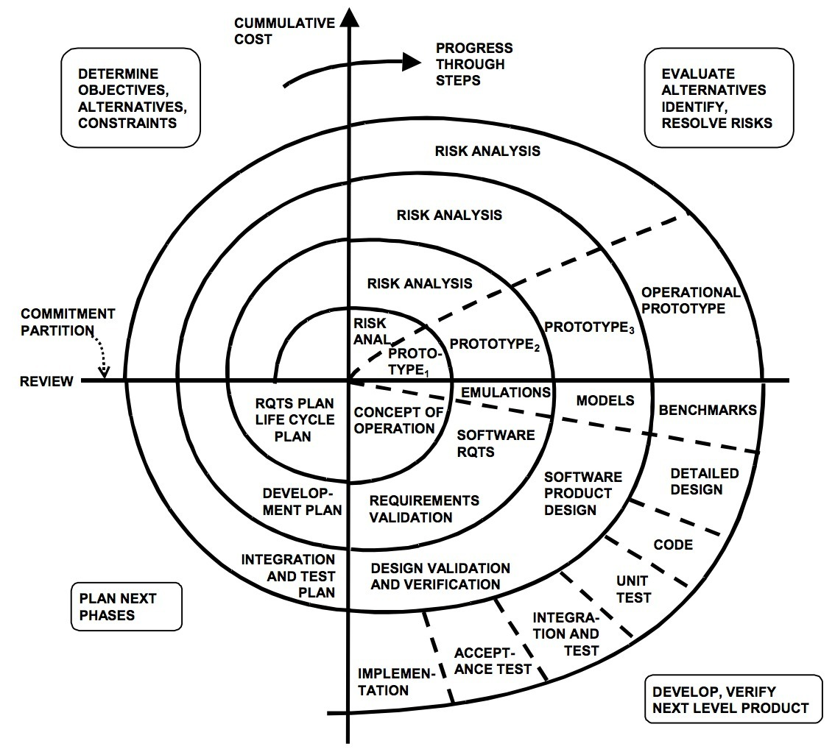

Waterfall Model
The Waterfall Model was the first Process Model to be introduced. It is also referred to as a linear-sequential life cycle model. It illustrates the software development process in a linear sequential flow. It is very simple to understand and use. In a waterfall model, each phase must be completed before the next phase can begin and there is no overlapping in the phases. The Waterfall model is the earliest SDLC approach that was used for software development.
This means that any phase in the development process begins only if the previous phase is complete. In this waterfall model, the phases do not overlap.
The waterfall model is a sequential (non-iterative) design process, used in software development processes, in which progress is seen as flowing steadily downwards (like a waterfall) through the phases of conception, initiation, analysis, design, construction, testing, production/implementation and maintenance. Despite the development of new software development process models, the Waterfall method is still the dominant process model with over a third of software developers still using it.

This model is depicted in the following diagram.

Work Plan (Gantt Chart)
The work plan is a document that consulting firms use to organize a project. It outlines the plan by which the company plans to complete a quality project within a given amount of time and in compliance with a set budget.
Gantt charts are useful tools for planning and scheduling projects. They allow you to assess how long a project should take, determine the resources needed and layout the order in which tasks need to be carried out. They are useful in managing the dependencies between tasks.

Project Schedule (Submission Calendar)
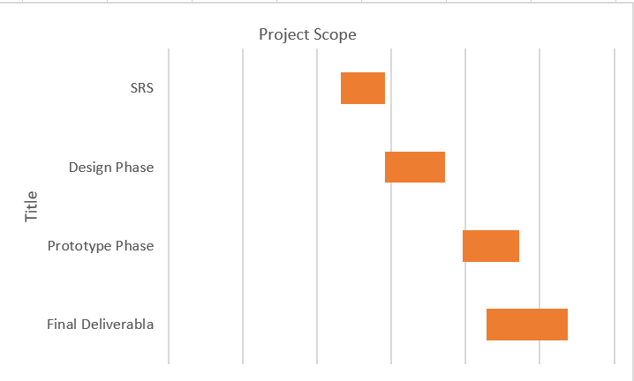

CHAPTER 2
Designing the Project

Introduction
In the evolving landscape of educational institutions, maintaining a strong connection with alumni is vital for career development and networking opportunities. This web-based platform will serve as a bridge between alumni, current students, and employers, facilitating job postings, applications, and professional networking. The portal will allow alumni to share career opportunities, students to seek internships or jobs, and employers to post vacancies, fostering a mutually beneficial ecosystem.
The system will feature a secure login for different user types (alumni, students, employers), profile management with resume uploads, and a job matching mechanism based on skills and experience. It will include an admin dashboard for oversight, ensuring data integrity and generating reports on job trends or user activity.
Purpose
In the evolving landscape of educational institutions, maintaining a strong connection with alumni is vital for career development and networking opportunities. This web-based platform will serve as a bridge between alumni, current students, and employers, facilitating job postings, applications, and professional networking. The portal will allow alumni to share career opportunities, students to seek internships or jobs, and employers to post vacancies, fostering a mutually beneficial ecosystem.
The system will feature a secure login for different user types (alumni, students, employers), profile management with resume uploads, and a job matching mechanism based on skills and experience. It will include an admin dashboard for oversight, ensuring data integrity and generating reports on job trends or user activity.
Scope
In the evolving landscape of educational institutions, maintaining a strong connection with alumni is vital for career development and networking opportunities. This web-based platform will serve as a bridge between alumni, current students, and employers, facilitating job postings, applications, and professional networking. The portal will allow alumni to share career opportunities, students to seek internships or jobs, and employers to post vacancies, fostering a mutually beneficial ecosystem.
The system will feature a secure login for different user types (alumni, students, employers), profile management with resume uploads, and a job matching mechanism based on skills and experience. It will include an admin dashboard for oversight, ensuring data integrity and generating reports on job trends or user activity.

Definitions, Acronyms and Abbreviations

Terms | Definition
Web Programming/System | Book Recommender System
SRS | Software Requirement Specifications
VU | Virtual University of Pakistan
Deliverables | These are the documents prepared during development life cycle of the SW project
GUI | Graphical User Interface
MySQL | A type of database management system
PW | Password
SW | Software
Architectural Representation (3R- Architecture Diagram)
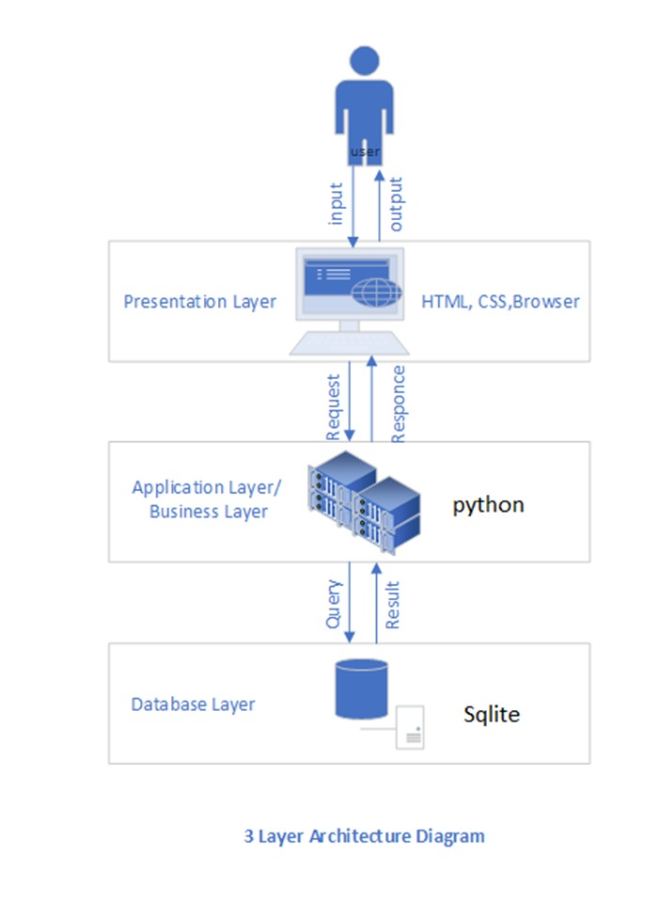

- Entity Relationship Diagram (ERD) (To be developed using Microsoft Visio or any other drawing software of your choice)
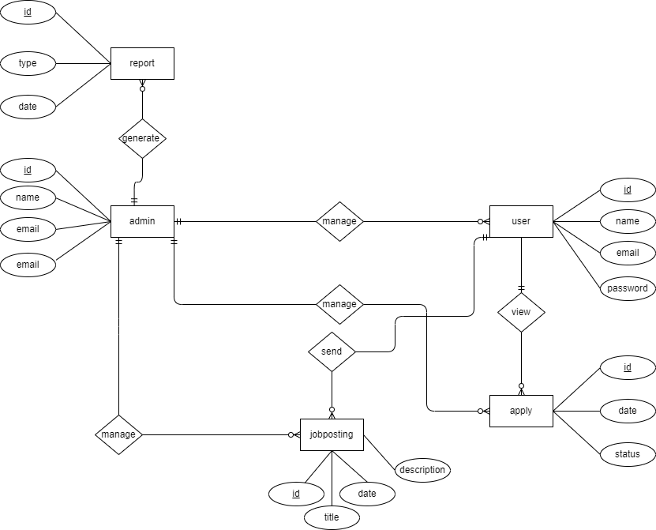

2. Sequence Diagrams (To be developed using Rational Rose or any other drawing software of your choice)
USER REGISTER:
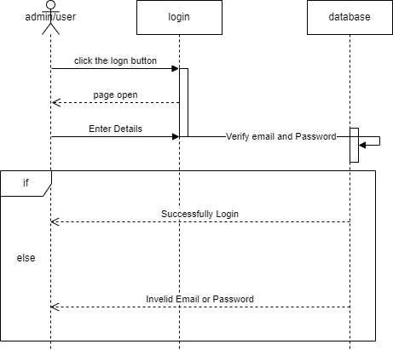

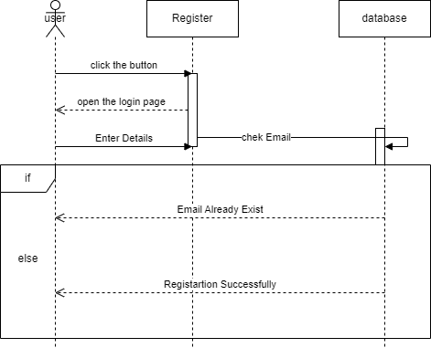

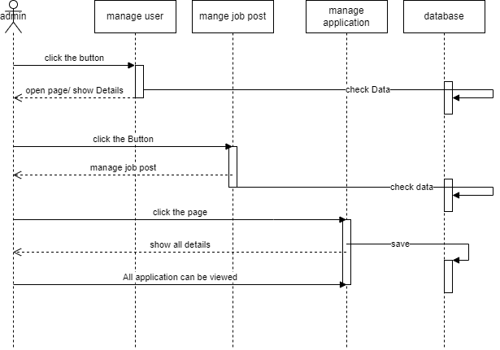

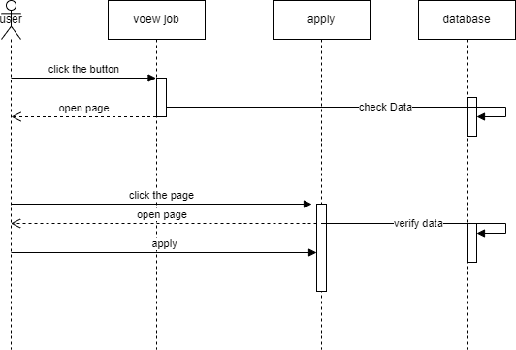

- Architecture Design Diagram
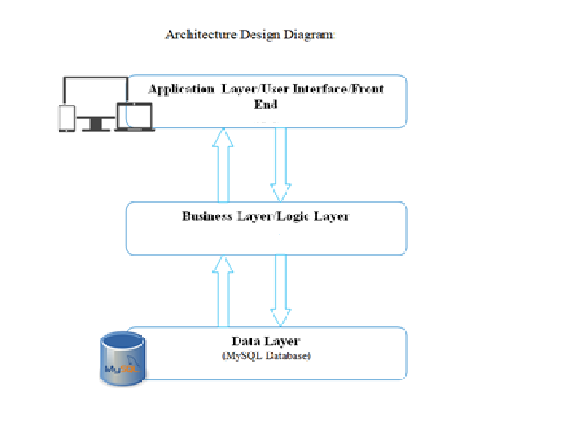
- Class Diagram

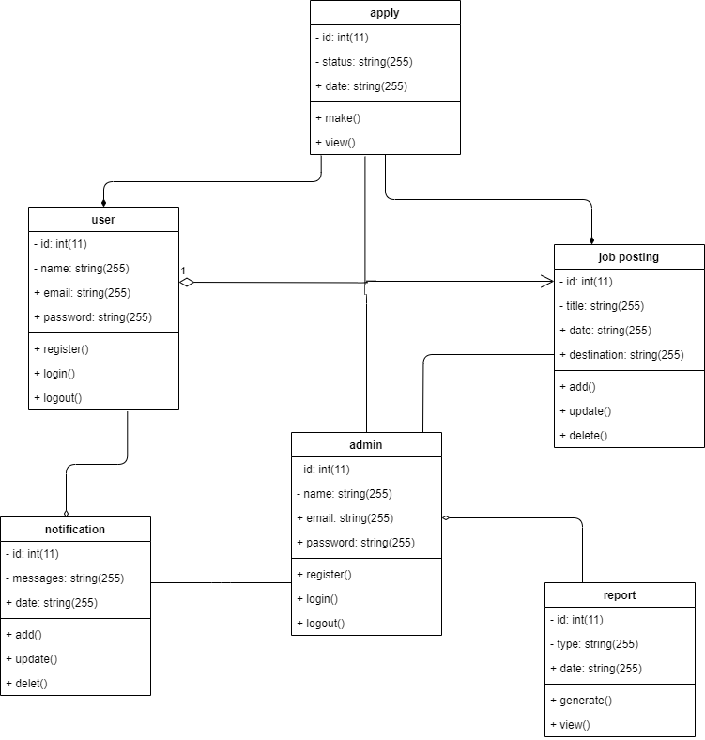

- Database Design

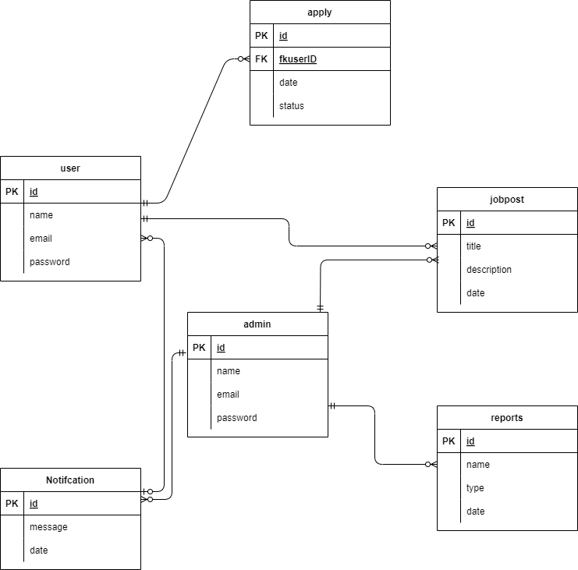

- Interface Design

COMPANU SIGN-UP:

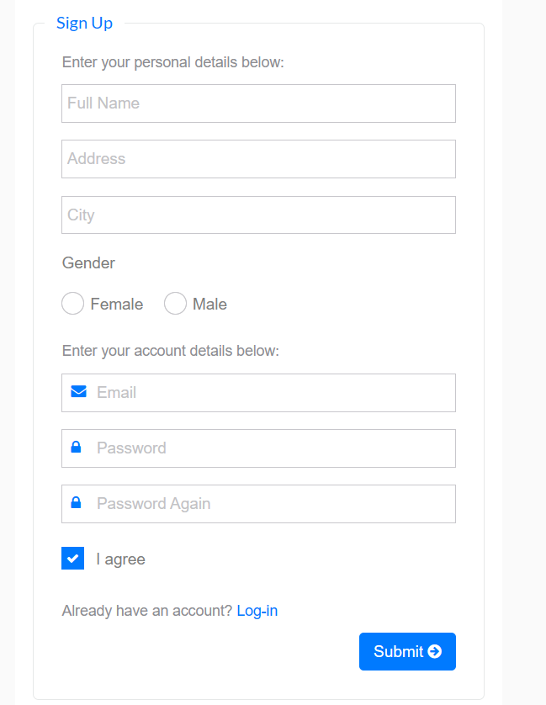

ADMIN LOGIN PAGE:
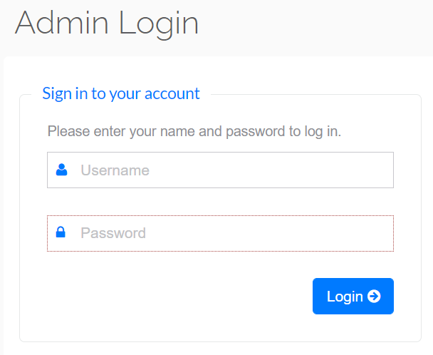

CHAPTER 3
Development

Development plan (Architecture Diagram)

REFERENCES

References
In order to develop our system, we have referenced a number of different systems. We have taken help from these systems for removing confusions and to make our system more useful.
However, the major sources were:
[1]. Software Engineering I and II (by Fakhar Lodhi)
This book is studied for different types of testing techniques and design models and Software Engineering Handouts Virtual University of Pakistan
[2]. W3 School (https://www.w3schools.com)
This website helps me in learning HTML, Python, CSS, BOOTSTRAP.
[3]. Modern Database Management (by Jeffrey A Hoffer)
To understand the different quarries of SQL server for using in our project.
[4]. Principles of Distributed Database System (by M. Tamer Ozsu and Patric Valdary)
We learn different database techniques making database tables and arranging them, form this book.
[5]. Modern Database Systems (By Date C.J) To understand database concepts and managing it using different techniques

APPENDIX

Section 1 | Gathering & Analyzing Info
Section 2 | Designing the Project
Section 3 | Development

